ICT Project Guidance

Design:  
User Supporting Services to Consider

Version:

0.4

Author:

Sky Sigal, Solution Architect

## Description

This document outlines for project stakeholders other systems to consider planning the delivery of, to improve discovery of the service itself, as well as wrap it with supporting services that improve the user experience.

## Synopsis

User Discovery Services are used to help Users discover the service and supporting services, and User Support Services help Users Rate and provide Feedback about the service, self-help themselves with online documentation, and request support if and as required.

## Contents

Description 1

Synopsis 1

Contents 2

Introduction 3

Background 3

Services 5

User Discovery Services 5

Enterprise Website 5

Project Specific Information Website 5

User Support Services 6

Self Help Documentation Service 7

Support Channel Service 8

User Feedback Services 9

Rating & Comments Management Service 9

Collaborator Feedback Services 10

Request/Issue Tracking Service 10

Conclusion 12

Appendices 13

Appendix A - Document Information 13

Versions 13

Images 13

Tables 13

References 13

Review Distribution 13

Audience 13

Structure 14

Diagrams 14

Terms 14

## Introduction

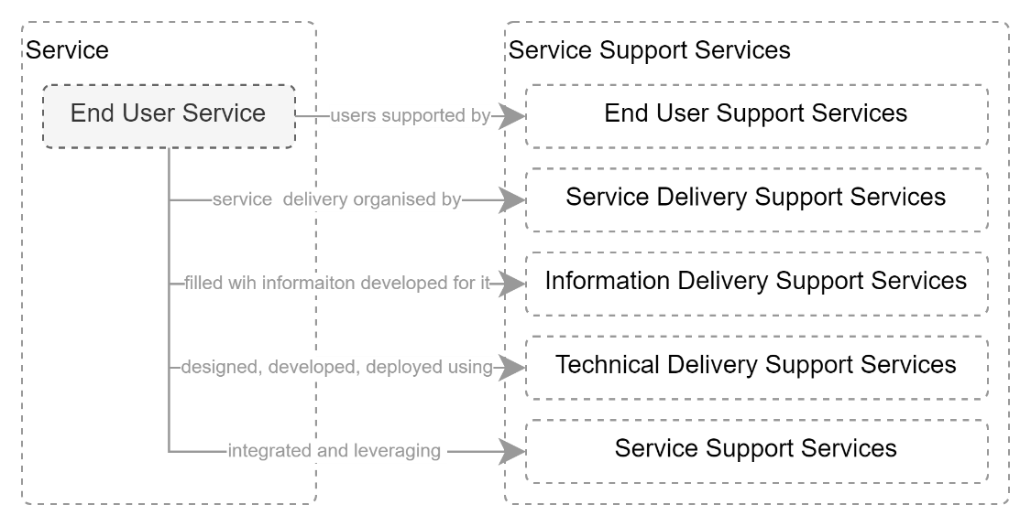

Figure : Service Supporting Services (HL)

In a related document (*ICT Project Guidance – Supporting Systems to Consider*), systems were categorised as being one of the following groups:

* **End User Stakeholder Support Services:** to help end users find and use the system,
* **Service Delivery Stakeholder Support Services:** to help manage the project to deliver the service,
* **Information Delivery Stakeholder Support Services:** to help manage information developed for delivery by the service,
* **Technical Delivery Stakeholder Support Services:** to manage the code, configuration, deployment, of the service,
* **Service Support Services:** IdP, SMTP, etc. services that the service integrates with and leverages.

This document outlines services to consider for assisting Users get the best experience using the system and provide useful feedback.

## Background

Users require additional services to help them have a quality experience[1].

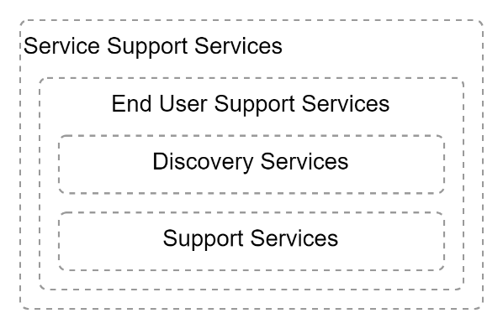

Figure : Categories of End User Support Services

The system can be classified as either User Discovery Services, or User Support Services.

# Services

## User Discovery Services

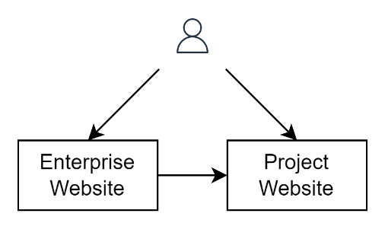

Figure : User Discovery Services (HL)

User Discovery services improve the discoverability of the service:

### Enterprise Website

The publicly accessible all-of-enterprise website (e.g.: *https://ourorganisation.tld*) is an important part of the process of making the service and its value known to new users.

Work should be commissioned to update the site to provide public users with short high-level summary of the service’s purpose, value, and relationship to other enterprise services, as well as provide a link to either the service itself, or to a dedicated project website that in turn provides a link to the service.

Consider ensuing the website’s Search Engine Optimisation (SEO) is highly specific and discoverable by public web search engines (e.g., Google, Bing, etc.).

### Project Specific Information Website

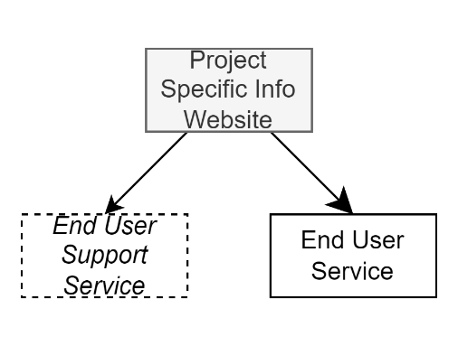

Figure : Project Specific Information Website purposes

The primary purpose of a project-specific website[2] is to wrap the project’s end-user service with publicly discoverable in-depth information about the service, its value, and relationship to other services offered by the enterprise.

However, it also fulfils other important outcomes – connecting the user to end user support services, discussed in the next section.

Note:  
As the service delivered to end users may be a SaaS that cannot easily be modified, current best practice is to use separate dedicated SaaS services to wrap it with access to self-help, assisted help, issue tracking and user feedback.

## User Support Services

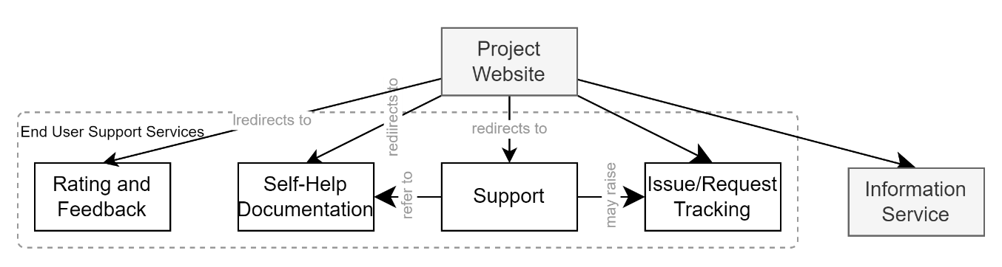

Figure : User Support Services

The purpose of User Support Services include:

* providing self-help material for users with self-agency,
* providing the means for users to rate and comment on the service,
* provide workflow managed support to users,
* improving service quality by collecting end user feedback used to inform the development and prioritisation of new work.

The above can be delivered by the services listed below.

### Self Help Documentation Service

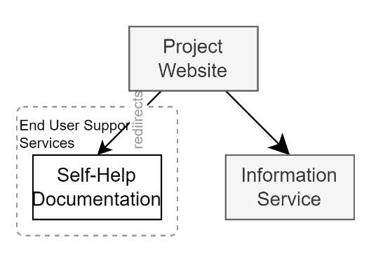

Figure : Self Help Documentation

Documentation services permit users with agency to self-help by reading indexed and crosslinked documentation.  
  
The clearer, more concise and complete the documentation is, the more support costs are decreased.

If the end-user service is SaaS based, documentation for the service will be provided by the vendor, either inline to their product, or external to it in a site they maintain.

If the end-user service is the only component used, it is possible to link the project specific website directly to the vendor provided documentation -- but this is uncommon as the service will generally be provided by multiple components (e.g., data is exported from the SaaS service to an organisation provided Microsoft BI service).

In such cases, the help documentation may be a dedicated site provided by the organisation that describes the services it has provided, and links to one or more vendor managed documentation locations for more in depth documentation specific to each vendor provided component[3].

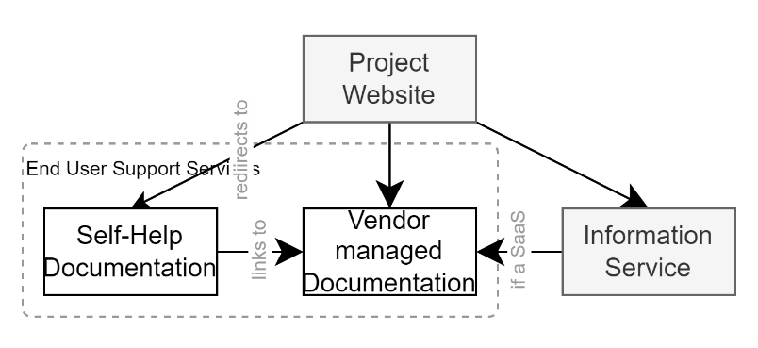

Figure : Self-Help Documentation (variation)

It is best provided via a specialised web-based service (e.g.: [*https://documentation.ourservice.ourorganisation.tld*](https://documentation.ourservice.ourorganisation.tld)) that is separate from the actual end-user business service ([*https://ourservice.ourorganisation.tld*](https://ourservice.ourorganisation.tld)) [4].

### Support Channel Service

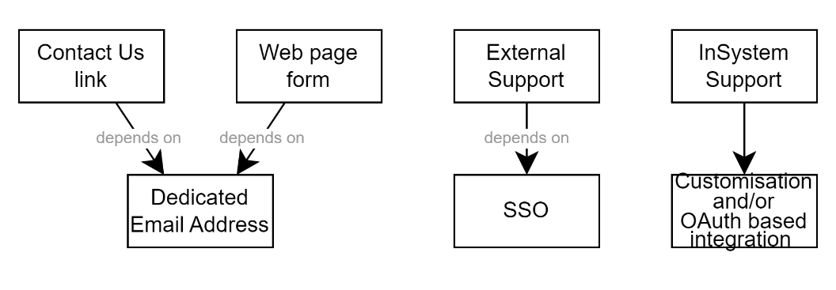

Figure : Common User Support Approaches

No matter how simple the application’s functionality, Users will require a means of requesting Support.

The most basic option to provide support to end users is by making available a generic “Contact Us” email address (e.g.: [*support@ourorganisation.tld*](mailto:support@ourorganisation.tld)) on the Organisation website, and hoping inquirers somehow indicate what system they are referring to.

Slightly better (but not much) is offering a Contact Us on the service specific information website, using an email address specific to the service (e.g.: [*ourservice.support@ourorganisation.tld*](mailto:ourservice.support@ourorganisation.tld)).

Optionally a form can be developed on the product specific website to collect a query or feedback, that in turn sends it to the service specific email address without disclosing to which email address it is being sent.

These approaches are relatively primitive, technically speaking, and depend on procuring and configuring an email account (e.g.: [*ourservice.support@ourorganisation.tld*](mailto:ourservice.support@ourorganisation.tldl) ), and processes put in place to regularly monitor the mailbox.

A better user experience is using a 3rd party SaaS service for managing Support request workflows via tracked conversations/support tickets.

The service can be delivered outside of the end-user service (e.g.: [*https://support.ourservice.ourenterprise.tld*](https://support.ourservice.ourenterprise.tld)), or within it, inline[5].

If outside, the project website and/or self-help documentation must be updated to refer and link to it.

Note:  
If the service is sufficiently configurable that a support system can be embedded, OAuth can be used to establish trust, injecting in the current Session User’s identifier.  
If the service is a 3rd party system, then establishing Single Sign On (SSO) would permit users avoiding having to re-sign-in to the support service.

If using an external service, it is required that the project website be updated to point to it.

While a Support Service’s primary purpose is to delivery support, and not track improvements to the system, it can be integrated with a Request/Issue tracking service.

## User Feedback Services

### Rating & Comments Management Service

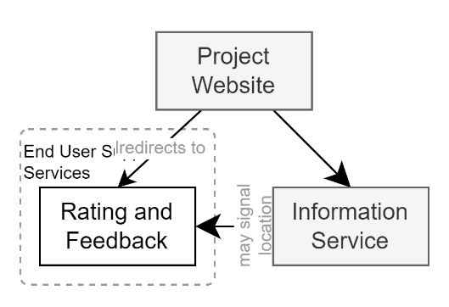

Figure : User Voice Management Service

Ratings and Comments permit users to record their perception[6] of the quality of service they received and leave a positive or negative comment intended primarily for other users, and not delivery stakeholders.

Note:  
It is important that processes are put in place to Moderate comments to protect the organisation and service’s reputation. And while it is common practice for a moderator to respond to negative comments with a propose to get in touch with assistance via a different channel (e.g.: a Support Channel), they are not intended for providing support.

## Collaborator Feedback Services

A third category – that of collaborator feedback services, as exemplified by GitHub Issues[7] -- is sometimes considered and sometimes used to stand in for a user support channel in the early days of a project.

However, it is important to disambiguate service Users from project Collaborators and use different channels for each.

For this reason, Collaborator Feedback Services are not listed here, and are instead described in *ICT Project Guidance – Supporting Systems to Consider for Technical Stakeholders*.

Note:  
while technical and collaborator feedback is common on open source-code libraries, and API services exposing this of type of feedback service to service consumers is not recommended.

### User Request/Issue Tracking Service

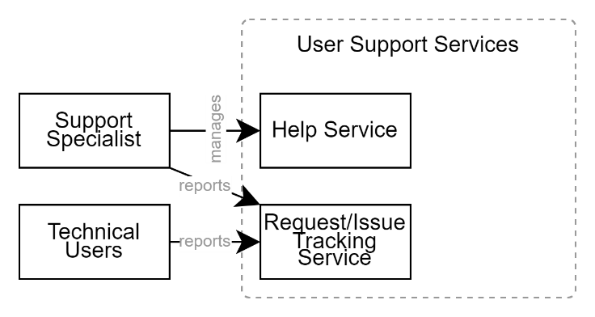

Figure : Request/Issue Tracking Service

A Request/Issue Tracking Service permits users to report Issues with the system and/or Requests changes be made.

While it is an end-user support service, such services are generally for a technical audience, as opposed to general users.

Additionally, a Help Support specialist may see a pattern emerge within raised support tickets and use the service to report it as an issue.

Alternatively -- and only if the service is for internal users only -- it is possible to provide them with direct access to the project delivery’s Work Item Management Service that is discussed later in this document.

While relatively easy to setup, this approach may rely on requiring users to have some form of training and induction to the delivery team’s processes. This can be required as these types of systems are often unable to limit access to the creation of new work items, while having only read-only access to issues and desire items posted by others.

Note:  
While there are lots of benefits of being transparent as to the progress of issues and desire statements through to being prioritised work items that are completed, there is a risk of data leakage if confidential information (configuration, integration, etc.) is added to notes and comments by developers.

A more secure and use-case specific solution is to have a User Voice Management Service for collecting end user desires and issues, that are picked up by stakeholder analysts to be converted into SMART statements in the Backlog of the Work Item Management Service (discussed next).

To facilitate accessibility by both internal and external users, consider using a web-based User Voice Management Service.

To facilitate authorisation, consider using a service that is integrated with web based IdPs that can federate back identification processes, to assist with identifying both organisation and public users.

To facilitate communicating to users the state of their ticket, consider using a User Voice Management Service that can be integrated with the Work Item Management Service so that signals from the Work Item Management Service can update the status of the posted Desire or Issue service.

# Conclusion

Offering services without the means to improve discoverability increases communication and change management costs. Offering services without the means to rate and recommend the service decreases adoption, increasing communication and promotion costs. Offering services without the means for users to self-help themselves decreases adoption of the service by users. Offering services without the means to ask for assistance and support again decreases adoption and increases user attrition.

Knowing what services to consider and plan for their delivery decreases the above risk to projects.

Appendices

Appendix A - Document Information

### Versions

0.1: Initial Draft

0.4 Removed Request/Issue Tracking Service

### Images

Figure 1: Service Supporting Services (HL) 3

Figure 2: User Support Services 4

Figure 3: Self Help Documentation 4

Figure 4: Self-Help Documentation (variation) 5

Figure 4: User Voice Management Service 5

Figure 6: Common User Support Approaches 6

### Tables

### References

*ICT Project Guidance – Supporting Systems to Consider*

*ICT Project Guidance – Supporting Systems to Consider for Technical Stakeholders*

**There are no sources in the current document.**

### Review Distribution

The document was distributed for review as below:

|  |  |
| --- | --- |
| Identity | Notes |
| Sandy Britain, Enterprise Architect |  |
| Rodney Snell, Business & Technical Lead |  |
| Russell Campbell, Project Manager |  |

### Audience

The document is technical in nature, but parts are expected to be read and/or validated by a non-technical audience.

### Structure

Where possible, the document structure is guided by either ISO-* standards or best practice.

### Diagrams

Diagrams are developed for a wide audience. Unless specifically for a technical audience, where the use of industry standard diagram types (ArchiMate, UML, C4), is appropriate, diagrams are developed as simple “box & line” monochrome diagrams.

### Terms

Refer to the project’s Glossary.

##### IT

: acronym for Information, using Technology to automate and facilitate its management.

##### ICT

: acronym for Information & Communication Technology, the domain of defining Information elements and using technology to automate their communication between entities. IT is a subset of ICT.

##### SaaS

: Software as a Service, where business service providers have an account with a rentable, managed service provided a technological service provider, configured to their specific needs. Business service providers do not have to concern themselves with the maintenance of underlying Platform or Infrastructure (web server, database server, OS, device, etc.). SaaS is always less expensive than PaaS, which is always less expensive than an IaaS based approach.

1. ISO-25022
2. a project specific site may be developed as a subgroup of related pages within the hierarchy of the enterprise (e.g.: https://ourorganisation.tld/projects/ourservice) or an independent web site (e.g.: https://information.ourservice.ourtenterprise.tld). There are different advantages and disadvantages to either approach.
3. Care is required to explain on the parent self-help documentation site the relation between the components.
4. It is rare for an end-user focused service to provide its own documentation in-service.
5. See [Inline Manual | Digital Adoption Platform](https://inlinemanual.com/)
6. See ISO-25022
7. [About issues - GitHub Docs](https://docs.github.com/en/issues/tracking-your-work-with-issues/about-issues)